|  |  |
| --- | --- |
| Date | 22 October, 2022 |
| Team ID | PNT2022TMID39931 |
| Project name | **Signs with Smart Connnectivity for Better Road Safety** |

# Milestone

* Technology has been evolving everyday and requirements for people in every situation for ease life is constantly increasing. Especially people who go for work are most in need of.
* Employees depend on their work, family, friends and caretakers. Some Workers like who are going for job for their family expenses have busy schedule and no time for anything. They suffer in traffic during emergency cases.
* So our project will help all the working employees to be free from traffic tension and other

Personal problems

Milestone 1:

Surveys of the projects are taken such that literature surveys were collected and studied and information related to the project were collected. Learned Employees problems such ass pains and gains and prepared the problem statements.

Milestone 2:

Listed the ideas by organizing a session and prioritized top most ideas based on the feasibility and importance.

Milestone 3:

Proposed solution, Problem solution, Solution architecture have been prepared that includes the novelty, feasibility of idea, its social impact and scalability of solution etc.

Milestone 4:

Customer journey maps, Functional requirements and data flow diagrams have been prepared to get to the next of the project.

Milestone 5:

Preparing activity list and sprint delivery plan to plan and deliver the development process of the project.

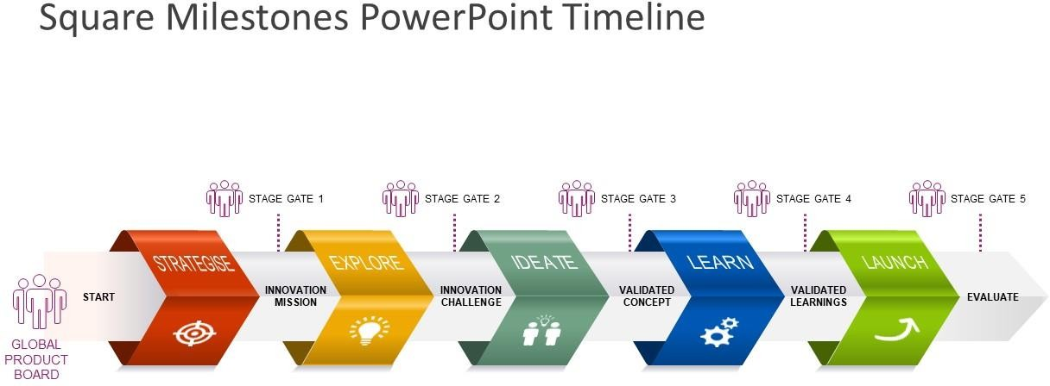

|  |  |
| --- | --- |
| Date | 22 October, 2022 |
| Team ID | PNT2022TMID39931 |
| Project name | **Signs with Smart Connnectivity for Better Road Safety** |

**Activity list**

* In project, planning is an important task to do for each team member.
* In this activity list we can see the list of activities that should be done by every member

**--->** 1. Information gathering and analysis of information.

---**>** 2. Requirement acknowledgement and project planning.

**--->** 3. Project development modules and improvement.

---**>** 4. Project implementation of algorithm and other needs.

---**>** 5. Testing the working and performance.

**--->** 6. Deploying the project to the society.